Utilizing machine learning to improve healthcare cost prediction on large public datasets

|  |  |  |  |
| --- | --- | --- | --- |
| Satwik † | Aneeket Yadav † | Rahul Garg† | A. Ravishankar Rao † * |
| Indian Inst. Of Tech.Delhi, India  satwik31102003@gmail.com | Indian Inst. Of Tech.Delhi, India  aneeketyadaviitdcse@gmail.com | Indian Inst. Of Tech.Delhi, India  rahulgarg@cse.iitd.ac.in | Fairleigh Dickinson U.  Teaneck, USA  raviraodr@gmail.com |
| †: All authors contributed equally to the research and the writing of this paper  *: Corresponding author | | | |

*Abstract*

Ensuring good health and well-being is a key United Nations Sustainable Development Goal (SDG). However, rising healthcare costs pose challenges, particularly in the U.S., where spending reached $4.9 trillion in 2023, accounting for 17.6% of GDP. This growing financial burden highlights the need for cost prediction models and improved price transparency.

This study addresses two key questions: (1) How can computational models predict healthcare costs accurately? (2) How can price transparency be improved? Using New York SPARCS data, and 2 million deidentifed patient records, we developed machine learning models to forecast treatment costs. Our ensemble-based CatBoost approach reduces prediction error (RMSE) by 55% compared to a single CatBoost model. We also optimize prediction coverage to balance accuracy and usability for hospitals and insurers.

Lack of price transparency remains a major issue, leading to significant market inefficiencies. Reports show U.S. healthcare prices far exceed those in other countries, largely due to pricing failures and non-standardized costs. Patients increasingly seek pre-treatment cost estimates, yet available data remains difficult to interpret. Our findings underscore the need for policy-driven transparency initiatives.

We also highlight the importance of a national health data system, which the U.S. lacks. Research using SPARCS data has identified regional health trends, helping guide public health policies. Expanding such efforts could enhance data-driven decision-making nationwide. By advancing predictive modeling and transparency initiatives, this research contributes to a more equitable and data-driven healthcare system.

Keywords: spatio-temporal analysis, data mining, trend analysis, healthcare, cost prediction.

# INTRODUCTION AND MOTIVATION

Good health and well-being are recognized by the United Nations as one of the 17 Sustainable Development Goals (SDGs) for global progress The healthcare sector is a major component of most economies, employing a substantial portion of the workforce. Offering accessible healthcare is a high priority item for governments globally, since it improves population health, increases workforce productivity, and helps people across all demographics live longer, healthier lives.

In 2023, the United States' healthcare spending reached approximately $4.9 trillion, marking a 7.5% increase from the previous year [1]. This expenditure accounted for 17.6% of the nation's Gross Domestic Product (GDP). Additionally, hospital care expenditures grew by 10.4% in 2023, the most substantial increase in nearly three decades. This growth in healthcare expenditure and costs is unsustainable, and is causing a crisis in the U.S. An article in the Wall Street Journal observed that “The killing of a health insurance executive in New York City prompted a furious outpouring of anger over the industry and healthcare prices. So just how much have healthcare costs and spending been going up?” [2].

Healthcare price transparency, which enables patients to access accurate cost information before making medical decisions, has become an increasingly important policy priority [3]. Research has extensively documented both the significant variation in hospital pricing and the general lack of transparency in healthcare costs [4-6].

We address two main research questions. (1) How can we develop an effective computational approach to accurately model and predict healthcare costs? And (2) How can we improve price transparency for healthcare costs?

The New York SPARCS (Statewide Planning and Research Cooperative System) datasets offer a valuable opportunity for researchers to address this issue. In most cases, healthcare data is highly protected and primarily accessible to hospital administrators and insurance companies. This is especially true in the U.S., where the absence of a national healthcare system means there is no centralized health database. Consequently, we utilize the NY SPARCS data [7] to develop and refine our approach and methodology. Our methodology combines analysis of large-scale anonymized patient records using big data processing techniques and building machine learning models to forecast costs of treatment.

We have made our analytical code publicly accessible [8], enabling other researchers to validate and build upon these methods, accelerating progress in healthcare analytics.

# BACKGROUND AND RELATED WORK

Atluri et al. [9] present a survey of research in spatio-temporal data mining. They mention several techniques including the clustering of time series and measuring spatial autocorrelation, which we have utilized in the current paper. Chen et al. investigated spatio-temporal trends in New York SPARCS based on data collected from 2005-2014 [10]. Murphy et al. investigated spatio-temporal trends in breast cancer occurrences using New York SPARCS data[11].

Lan et al. [12] developed a cost prediction model using around 37,000 patients. Other researchers, including Yu et al. [13], Zhai et al. [14] and Kartchner et al. [15] have also developed models for healthcare cost prediction.

# Design and Methods

In our previous work, we developed an open-access data analytics toolkit to enable the analysis of deidentified patient records from the New York State Department Of Health, Statewide Planning and Research Cooperative System (SPARCS) [7]. We predicted the costs of medical procedures [6, 16-18] identified outliers [19], and examined trends in mental health [20].

We deployed a Python-based workflow with the following components: Python Pandas, Scikit-Learn, Matplotlib, and Seaborn. The data flow in our system is shown in Figure 1.

We examined more than 2 million de-identified patient records from 2022 in SPARCS [21]. Each record contains 34 features, demographic descriptors of a patient’s race, ethnicity, and age; including geographic descriptors of the hospital; medical descriptors related to the Clinical Classification Software Refined (CCSR) diagnosis description, All Patient Refined Diagnosis Related Groups (APR DRG) description, length of stay, patient disposition, severity of illness, payment descriptors, the total charges and the total cost of the procedure. The CCSR diagnosis code refers to the code used by the Clinical Classifications Software system [22].

While previous work has focused on creating predictive models using random forests and gradient boosting, our goal was to make high confidence predictions by designing a model which may choose to not predict when it is not sufficiently certain about the results. To this end, we train 2 models, termed *Model 1* and *Model 2*.

*Model 1* reports the root mean squared error (RMSE) by removing the top 1% cases with highest mean squared errors post prediction.

*Model 2* uses an ensemble of CatBoost predictors, and uses their outputs to decide whether to provide a prediction for a given input value. This decision is made independently for each input value provided. This method introduces a trade-off between the error rate and the coverage of inputs, as the model may choose to predict only those inputs that it is very certain about. When the model predicts very few inputs, its error is likely to be low. In order to balance the two metrics of error rate and coverage, we set the hyperparameters so that the model chooses to predict for more than 98% coverage. This figure may be adjusted subjected to the degree of precision required by the end-user of the model, which could be a hospital or healthcare provider. In this setting, *Model 2*’s objective is to approach *Model 1*’s accuracy and coverage.

## Feature Selection and Encoding

There are several features that are redundant in the dataset. For instance, the CCSR diagnosis description provides a textual value for a given CCSR diagnosis code. Hence, it is not necessary to use both these features, and we ignore the CCSR diagnosis description. Accordingly, we use the following features to train our models: length of stay, hospital service area, hospital county, operating certificate number, age group, gender, race, ethnicity, type of admission, patient disposition, CCSR diagnosis code, CCSR procedure code, APR DRG code, APR MDC code, APR severity of illness, APR risk of mortality, APR medical surgical, payment typology 1, and emergency department indicator. We target encode all these columns except length of stay which is a numerical feature. The values were then normalized using the mean and standard deviation. Missing values were then imputed by the mean value of the corresponding feature. The data was randomly split in train and test sets in an 80-20 ratio.

## Denoising

Typically, cost data contains outliers with very high costs which affect a model’s precision. We observed that removing the top N% percent of the full dataset based on total costs significantly improved the model’s confidence and predictive power. We use the value of N=10. Let’s call the models trained and evaluated on this dataset to be *Model 1*\* and *Model 2*\*.

## Machine Learning Algorithm

Model 1

*Model 1* is trained using the XgBoost algorithm, due to gradient boosting efficiency, L1/L2 regularization, and parallelized execution. It employs tree pruning, early stopping, and custom loss functions, ensuring robustness. The training parameters were as follows:

{objective:'reg:squarederror',max_depth:10, learning_rate: 0.05, num_boost_rounds: 3000, L1/L2 regularization: enabled, pruning: enabled, early_stopping: enabled}[18]

Model 2

We train an ensemble of 10 CatBoost models. We then consider the standard deviation of predicted values of total cost computed by the ensemble. The standard deviation behaves as a measure of model uncertainty. *Model 2* predicts only the test examples whose standard deviation is less than a specified threshold. The RMSE is then calculated for these predictions. The training parameters were as follows:

{objective:'RMSE' (default), max_depth: 6 (default), learning_rate:0.03 (default), num_boost_rounds: 1000 per model, L2 regularization: 3 (default), pruning: symmetric trees, early_stopping: enabled}

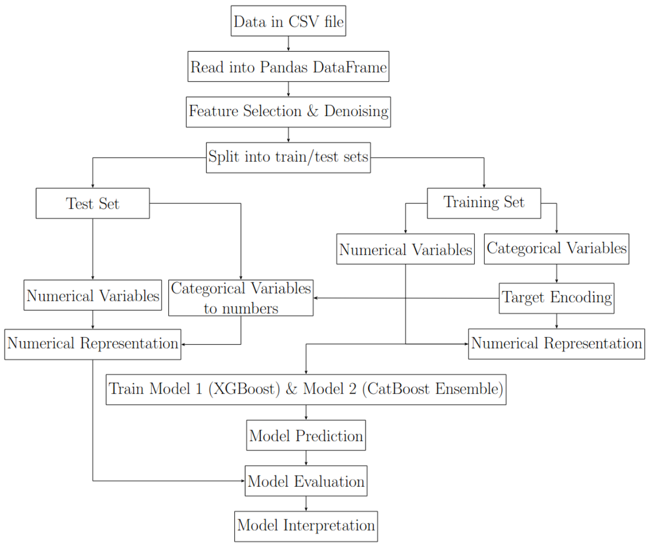

Figure 1: Processing steps used in our system.

# RESULTS

We report the results when the model training is performed on a CPU.

|  |  |  |  |  |
| --- | --- | --- | --- | --- |
| Model | MAE | RMSE | Trimmed RMSE  (99%) | Coverage |
| *Model 1* | 5323.55 | 23097.62 | 7580.61 | - |
| *Model 1\** | 2312.19 | 3777.91 | 3261.35 | - |
| *Model 2* | 5181.44 | 10511.96 | - | 98.19% |
| *Model 2\** | 2862.57 | 4358.28 | - | 100% |

Table 1: Comparing the performance of different models. MAE is the Mean Absolute Error and RMSE is the Root Mean Squared Error, measured in dollars.

# INTERPRETATION OF RESULTS

From Table 1, *Model 1* and *Model 1\** are predicting costs for every input value in the test dataset. However, *Model 2* and *Model 2\** predict only those input values for which they are confident.

It is to be noted that the quantities truly comparable for our purpose are the Root Mean Squared Error(RMSE) of *Model 2* (*Model 2*\*) and Trimmed RMSE of *Model 1* (*Model 1\**). RMSE of *Model 2*, computed on the selected test examples, is higher than the Trimmed RMSE of *Model 1* (calculated after trimming the outliers in the top 99th percentile of the RSME values).

We note that *Model 1\** is rejecting the inputs post-prediction, whereas *Model 2* is rejecting the inputs individually based on the expected variance of the ensemble’s predictions. Ideally, we would like *Model 2* to emulate *Model 1\**. Hence, it is instructive to compare the choices made by the two models in terms of the samples they rejected.

We found significant similarity between the specimens rejected by *Model 1* post prediction (i.e. *Model 1\**) and those not predicted by *Model 2*. This was done by observing for each feature, the proportion in which each of its values exists in the removed test examples while taking into consideration the class imbalance. Thus, for a given feature and its given value, its fraction in the rejected specimens was divided by its fraction in the full dataset. For categorical features where the number of possible values was small, the choices of *Model 2* generally completely align with the choices of *Model 1*, while for larger number of values, the top choices remain common for both models as can be seen in Figure 2. Patients who are older typically tend to have more health complications with higher cost variability, and this is reflected in Figure 2, where a larger number of rejected inputs come from patients in higher age brackets.

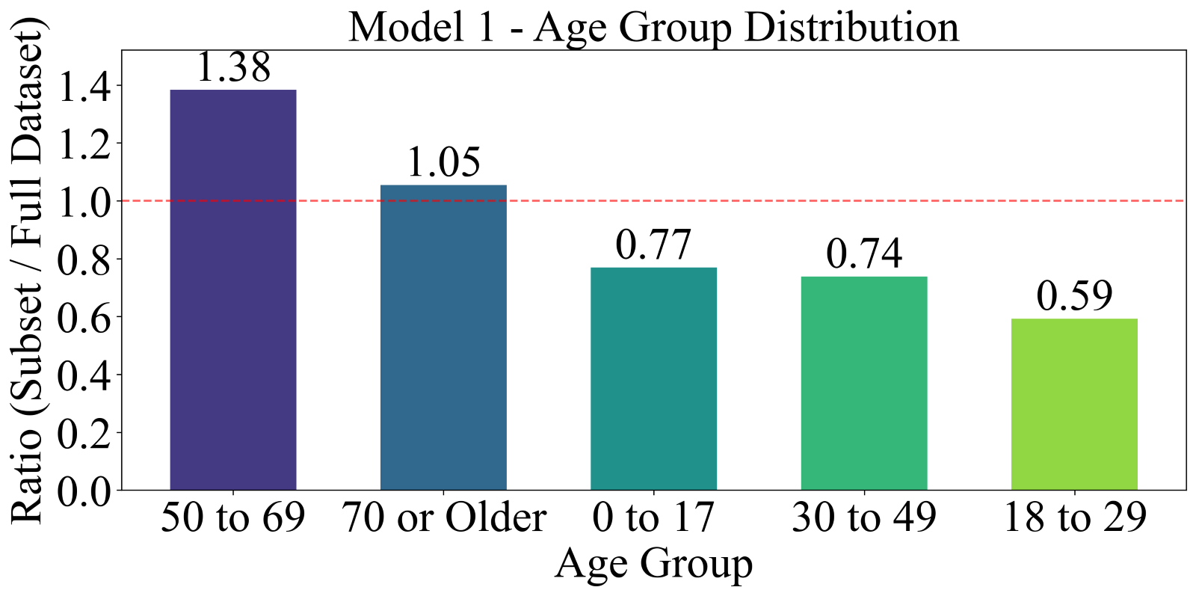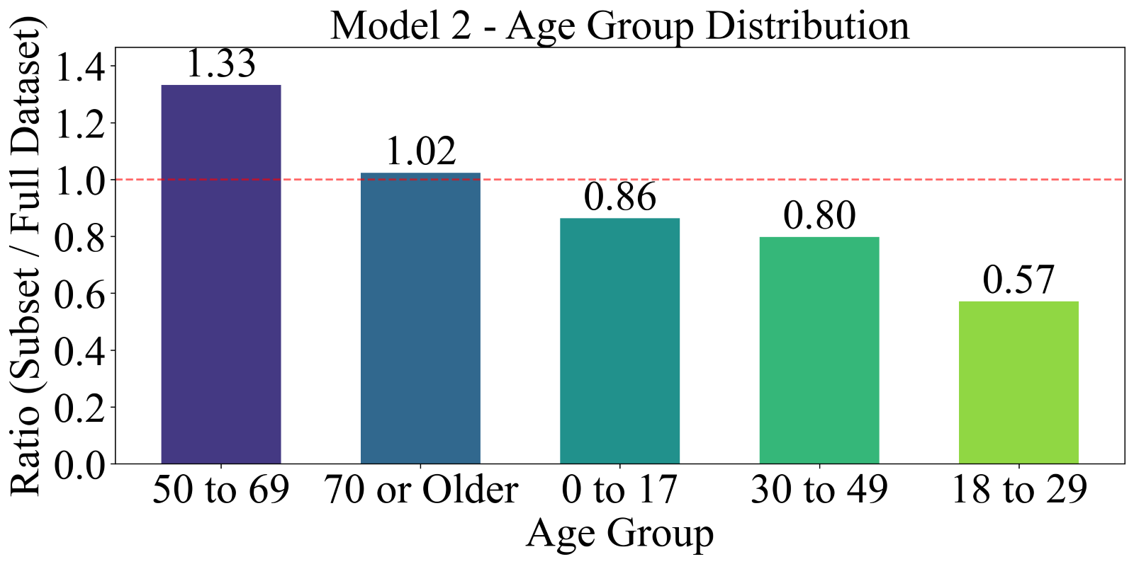

Figure 2: A comparison of the distribution of removed examples based on different features.

Since there is a tradeoff between the coverage and accuracy of the model, we measured the RMSE vs coverage for *Model 2* which is depicted in Figure 3. This figure shows that as the coverage increases to 100%, the RMSE also increases.

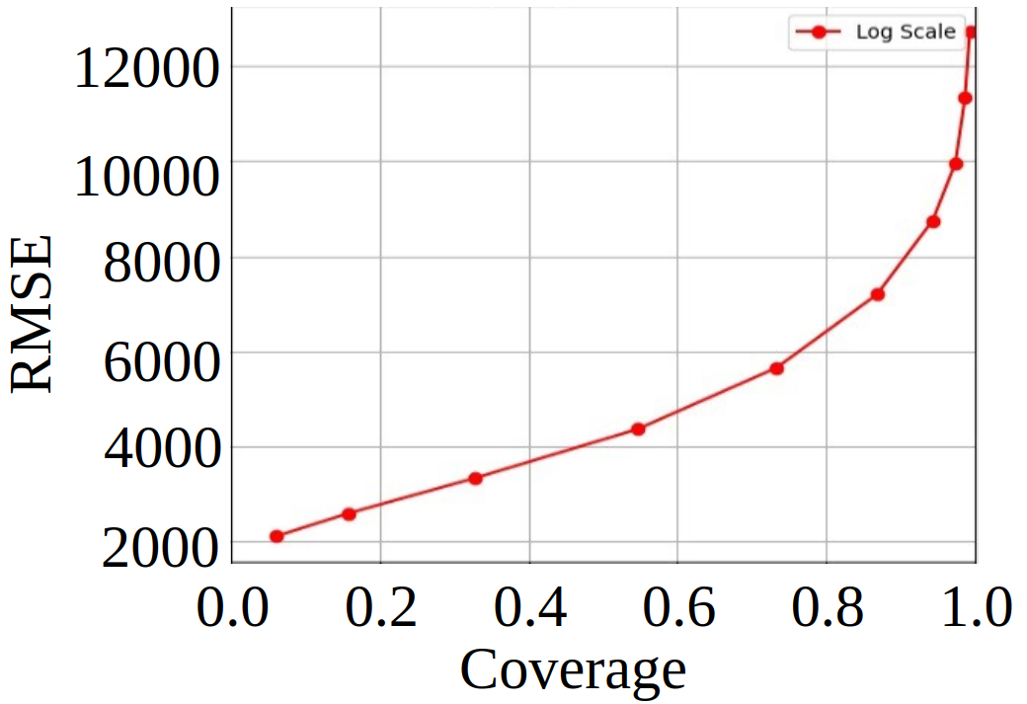

Figure 3: RMSE vs Coverage (Logarithmic Threshold Variation)

Moreover, as is clear from Table 1 and definitions of *Model 1*\* and *Model 2*\*, removing the data items from the original dataset corresponding to the top N% data with respect to total costs has a significant impact on the outcomes. This is perhaps because these values constitute the majority of outliers which are harder to predict. We therefore studied the variation of Trimmed RMSE of *Model 1* and RMSE of *Model 2* against the percentage of data removed which are shown in Figure 4.

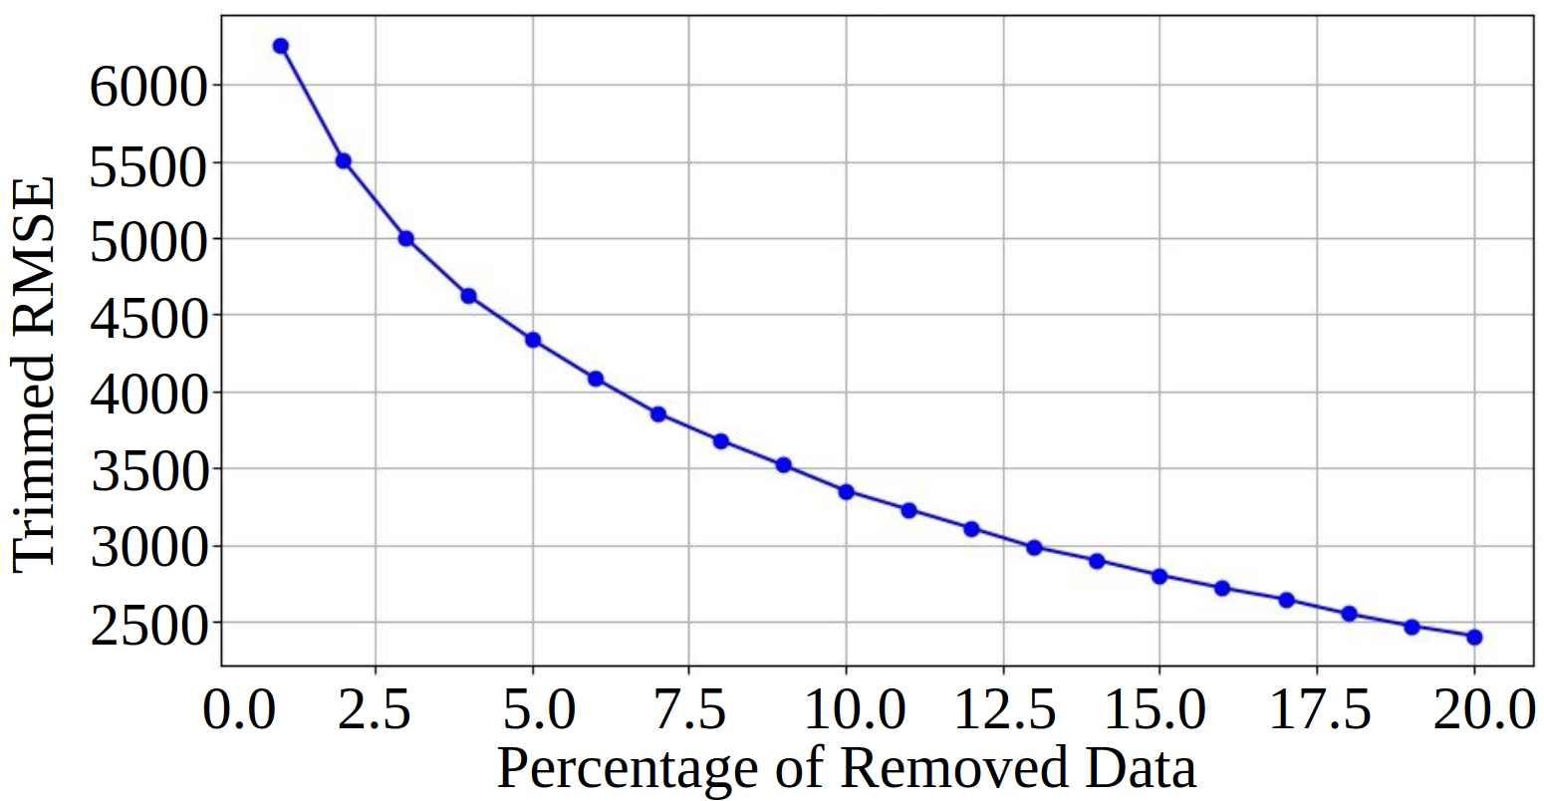

(A) Trimmed RMSE vs percentage of data removed for *Model 1*.

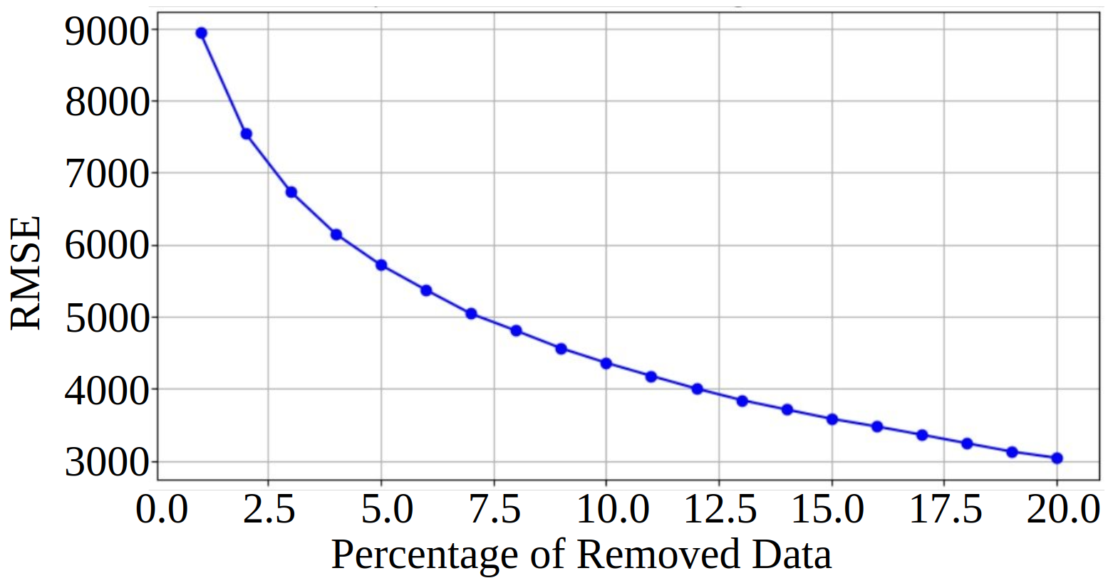

(B) RMSE vs percentage of data removed for *Model 2*.

Figure 4: Computing the effect of outlier removals on the RMSE.

# DISCUSSION

Our results show that it is advantageous to use a model that can determine the confidence level of its predictions. This confidence level can be used to filter model predictions to achieve the desired tradeoff between coverage and accuracy as shown in Figure 3. Such a model can be deployed in production by hospitals, healthcare providers and insurance companies to better predict expected healthcare costs.

From Figure 3 we observe that there is a tradeoff between the coverage of the dataset in terms of the percentage of samples predicted and the expected error. We can reduce the RMSE by accepting a slightly lower coverage of the samples predicted, which could be advantageous in a production setting.

A majority of patients want to know healthcare costs before receiving services, with more than one-third actively seeking price information prior to primary care visits [23]. This issue of advance price information has expanded beyond just uninsured patients to become increasingly relevant for those with private insurance, as higher deductibles have led to greater out-of-pocket expenses. The percentage of privately insured adults with deductible plans has increased substantially from 60% to 75% between 2003 and 2014 [23].

Berwick identified six major factors that contribute to waste and inefficiency in the U.S. healthcare system [24]. One such factor is pricing failure, due to market distortions in healthcare pricing which occur when costs significantly deviate from what would be expected in an efficient market - namely, the true production costs plus a reasonable profit margin. For example, because of the absence of effective transparency and efficient markets, US prices for diagnostic procedures such as MRI and CT scans are several times higher than identical procedures in other countries. Though Berwick’s article [24] was written in 2012, a recent study by the International Federation of Health Plans in 2024 confirms that the U.S. still sees elevated costs for advanced diagnostic procedures compared to Europe and Australia [25].

The International Federation of Healthcare Plans is a global network of insurers and payers from over 40 countries that shares knowledge to tackle challenges in healthcare. According to their recent report, healthcare costs in the US remain the highest globally. For instance, the median cost of a coronary bypass surgery in the U.S. is $89,094, much higher than $17,741 in Australia and $10,734 in Spain [25].

Shrank et al. [26] recommend steps to tackle pricing inefficiencies. These include efforts to standardize prices of services for the insurers and implementing cost transparency efforts for patients. As we demonstrate in the current paper, it is difficult for patients to directly interact with copious amounts of healthcare data. They are better served by utilizing models that can accurately estimate costs for their specific health conditions. Our current research is an early but important step in working towards a useful price transparency system that will benefit all.

Williams [27] observes that there is no national health data system in the US. A comprehensive, secure national health data system would connect individual health records, population health statistics, and community-level health determinants. This integrated view would enable decision-makers to better understand health risks faced by different communities and develop targeted, effective interventions to address these challenges. Williams [27] recommended that every state should designate an entity for collecting, sharing, and using data from clinical, public health, social determinants, and administrative data. The data from the New York State SPARCS program has benefited researchers and guided healthcare interventions.

Trinh et al. [28] utilized SPARCS data to identify specific regions of New York city where inhabitants are more likely to experience influenza and asthma [28]. Rao et al. identified regions in New York state with higher incidences of schizophrenia and cardiac disease [18]. These research efforts continue to provide insights to policy makers to improve healthcare delivery for the well-being of the populations they serve.

As healthcare costs continue to rise, exploring non-pharmaceutical interventions and complementary approaches becomes increasingly vital, particularly for disease prevention [18]. Increasing attention is being paid to the health benefits of social engagement, spiritual activities, and respiratory exercises. Recently, warnings about alcohol consumption have been raised by the Surgeon General of the US [29]. Additionally, there is worldwide momentum in studying integrative, complementary, and alternative medicine approaches, with major research support coming from institutions like the U.S. National Institutes of Health [30], European Union organizations [31], and the Indian government [32].

# Conclusion

The results of this study highlight the importance of using models that incorporate confidence levels in predicting healthcare costs. By adjusting the tradeoff between coverage and accuracy, healthcare providers, hospitals, and insurance companies can better predict costs, thereby improving the transparency of healthcare pricing. Our analysis demonstrates that the ensemble model using CatBoost predictors is able to emulate the model that rejects cases with the highest RMSE post prediction, thus demonstrating its ability to make high confidence predictions while maintaining sufficient coverage.

However, the broader issue of healthcare pricing transparency remains a critical challenge. While many patients actively seek price estimates prior to treatment, the lack of effective transparency continues to drive market inefficiencies, with U.S. healthcare costs significantly exceeding those in other countries. This issue is exacerbated by rising deductibles and out-of-pocket expenses, making cost estimation crucial for all patients, not just the uninsured.

Addressing these challenges requires a standardized pricing system and better models for cost prediction, as well as policy-driven initiatives to improve transparency. The research demonstrates that predictive models can guide patients in making informed decisions and promote efficient resource allocation. Ultimately, data-driven solutions and efforts to create a national health data system will enhance healthcare delivery, reduce waste, and improve the well-being of populations.

##### references:

[1] (2023) National Health Expenditures 2023 Highlights *Center for Medicare and Medicaid services, cms.gov*. Available: <https://www.cms.gov/files/document/highlights.pdf>

[2] (2024, Dec. 18) Why Are Americans Paying So Much More for Healthcare Than They Used To? *Wall Street Journal*.

[3] B. Saloner, L. C. Cope, K. Hempstead, K. V. Rhodes, D. Polsky, and G. M. Kenney, "Price transparency in primary care: can patients learn about costs when scheduling an appointment?," *Journal of general internal medicine,* vol. 32, pp. 815-821, 2017.

[4] A. W. Mathews. (2022, June 8) Hospitals Face Penalties for First Time for Failing to Make Prices Public. *Wall Street Journal*.

[5] A. Mathews. (2021, April 14, 2021) Coding to Hide Health Prices from Web Searches Is Barred by Regulators. *Wall Street Journal*.

[6] A. R. Rao, R. Jain, M. Singh, and R. Garg, "Predictive interpretable analytics models for forecasting healthcare costs using open healthcare data," *Healthcare Analytics,* vol. 6, p. 100351, 2024.

[7] "New York State Department Of Health, Statewide Planning and Research Cooperative System (SPARCS)." <https://www.health.ny.gov/statistics/sparcs/> (accessed Oct. 5, 2022).

[8] "github.com/fdudatamining/framework, Base Frame Work for Data Mining." [Online]. Available: github.com/fdudatamining/framework.

[9] G. Atluri, A. Karpatne, and V. Kumar, "Spatio-temporal data mining: A survey of problems and methods," *ACM Computing Surveys (CSUR),* vol. 51, no. 4, pp. 1-41, 2018.

[10] X. Chen, Y. Wang, E. Schoenfeld, M. Saltz, J. Saltz, and F. Wang, "Spatio-temporal analysis for New York State SPARCS data," *AMIA summits on translational science proceedings,* vol. 2017, p. 483, 2017.

[11] F. Murphy, K. Abell-Hart, and F. Wang, "A Fine-grain Geospatial and Demographic Analysis of Breast Cancer Patterns in New York State," in *2021 IEEE International Conference on Big Data (Big Data)*, 2021: IEEE, pp. 5614-5619.

[12] Z. Lan, G. Zhou, Y. Zhang, Y. Duan, W. Yan, and C. Chi, "Healthcare expenditure prediction for crowd with co-existing medical conditions," in *2019 5th International Conference on Big Data Computing and Communications (BIGCOM)*, 2019: IEEE, pp. 303-307.

[13] S. Yu, M. Matsumori, and X. Lin, "Prediction Accuracy Improvement on Disease Risk and Cost Prediction Model," in *2022 International Symposium on Electrical, Electronics and Information Engineering (ISEEIE)*, 2022: IEEE, pp. 103-107.

[14] Y. Zhai, Q. Tai, Y. Zhao, P. Wang, and Y. Feng, "Health Insurance Cost Prediction Model Based on Big Data Analysis," in *2024 International Conference on Computing, Robotics and System Sciences (ICRSS)*, 2024: IEEE, pp. 295-300.

[15] D. Kartchner, A. Merrill, and J. Wrathall, "Cost reduction via patient targeting and outreach: a statistical approach," in *2017 IEEE International Conference on Healthcare Informatics (ICHI)*, 2017: IEEE, pp. 513-517.

[16] A. R. Rao, R. Jain, M. Singh, and R. Garg, "Machine Learning Models For Patient Medical Cost Prediction and Trend Analysis Using Open Healthcare Data," in *2023 IEEE 3rd International Conference on Electronic Communications, Internet of Things and Big Data (ICEIB)*, 2023: IEEE, pp. 292-296.

[17] R. Jain, M. Singh, A. R. Rao, and R. Garg, "Predicting hospital length of stay using machine learning on a large open health dataset," *BMC Health Services Research,* vol. 24, no. 1, p. 860, 2024.

[18] A. R. Rao and R. Janbandhu, "Spatio-Temporal Data Mining for Public Health by Using Large-Scale Datasets," in *2024 4th International Conference on Innovative Research in Applied Science, Engineering and Technology (IRASET)*, 2024: IEEE, pp. 1-7.

[19] A. R. Rao, S. Garai, S. Dey, and H. Peng, "PIKS: A Technique to Identify Actionable Trends for Policy-Makers Through Open Healthcare Data," *SN Computer Science,* vol. 2, no. 6, pp. 1-22, 2021.

[20] A. R. Rao, S. Rao, and R. Chhabra, "Rising mental health incidence among adolescents in Westchester, NY," *Community mental health journal,* pp. 1-11, 2021.

[21] "New York State Department Of Health, Statewide Planning and Research Cooperative System (SPARCS)." <https://www.health.ny.gov/statistics/sparcs/> (accessed.

[22] "CCS (Clinical Classifications Software) - Synopsis." <https://www.nlm.nih.gov/research/umls/sourcereleasedocs/current/CCS/index.html> (accessed 1/13/2022.

[23] B. Saloner, L. C. Cope, K. Hempstead, K. V. Rhodes, D. Polsky, and G. M. Kenney, "Price transparency in primary care: can patients learn about costs when scheduling an appointment?," *Journal of general internal medicine,* vol. 32, no. 7, pp. 815-821, 2017.

[24] D. M. Berwick and A. D. Hackbarth, "Eliminating waste in US health care," *Jama,* vol. 307, no. 14, pp. 1513-1516, 2012.

[25] (2024) International Healthcare Cost Comparison Report 2024. *International Federation of Health Plans*. Available: <https://ifhp.com/international-healthcare-cost-comparison-report-2024/>

[26] W. H. Shrank, T. L. Rogstad, and N. Parekh, "Waste in the US health care system: estimated costs and potential for savings," *Jama,* vol. 322, no. 15, pp. 1501-1509, 2019.

[27] M. A. Williams and G. Seidman. (2024, Jan 17.) Filling the gaps in U.S. health data. *Harvard Public Health: Policy and Practice*. Available: <https://harvardpublichealth.org/policy-practice/the-u-s-public-health-data-system-is-weak-heres-how-we-fix-it>

[28] P. Trinh, T. H. Jung, D. Keene, R. T. Demmer, M. Perzanowski, and G. Lovasi, "Temporal and spatial associations between influenza and asthma hospitalisations in New York City from 2002 to 2012: a longitudinal ecological study," *BMJ open,* vol. 8, no. 9, p. e020362, 2018.

[29] J. H. Tanne, "Alcoholic drinks should carry cancer warnings, says US surgeon general," *BMJ,* vol. 388, p. r15, 2025, doi: 10.1136/bmj.r15.

[30] B. J. Stussman, R. R. Nahin, P. M. Barnes, and B. W. Ward, "US physician recommendations to their patients about the use of complementary health approaches," *The Journal of Alternative and Complementary Medicine,* vol. 26, no. 1, pp. 25-33, 2020.

[31] E. L. Fjær, E. R. Landet, C. L. McNamara, and T. A. Eikemo, "The use of complementary and alternative medicine (CAM) in Europe," *BMC complementary medicine and therapies,* vol. 20, no. 1, pp. 1-9, 2020.

[32] D. Shankar and B. Patwardhan, "AYUSH for New India: Vision and strategy," *Journal of Ayurveda and integrative medicine,* vol. 8, no. 3, p. 137, 2017.